BSCI/BSCCT Education Site user FAQ

How do I get access to the BSCI/BSCCT education site?

BSCI/BSCCT members will automatically be resisted for the BSCI/BSCCT education site (hosted on Moodle). You will automatically receive an email to say that you have been registered on the BSCI/BSCCT education site.

I have forgotten my password - how do I reset my password?

Click on “Lost password” on the login page. You can use your BSCI number or email address to reset your password.

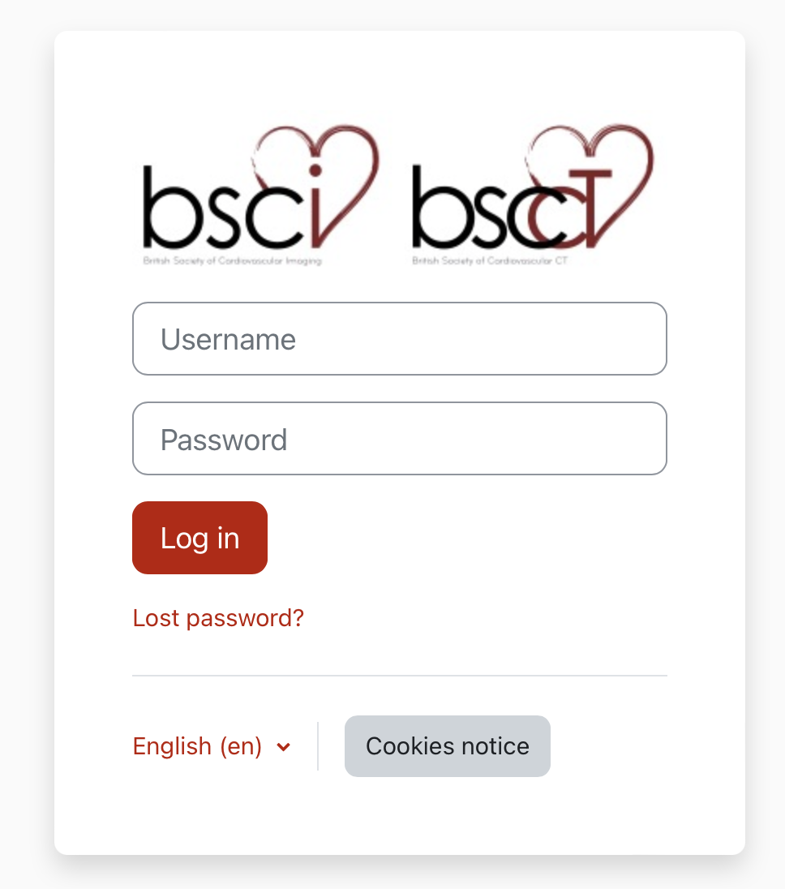

I have a question about the BSCI/BSCCT education site – how do I send this?

For any questions about the BSCI/BSCCT education site please email membership@bsci.org.uk.

