BSCI/BSCCT Moodle user how to access courses

- You will shortly receive an email saying that you have been registered on the BSCI/BSCCT education site. (The email will come from noreply@bsci.moodlecloud.com and be entitled “BSCI/BSCCT education: New user account”). This will give you your username (which will be your BSCI membership number) and a temporary password. Please login as soon as you are able and change your password. You will then be able to access the educational content on the site.

- Go to https://bsci.moodlecloud.com

- Login

- Accept the privacy and cookies policies.

- Click on Home in the top menu bar

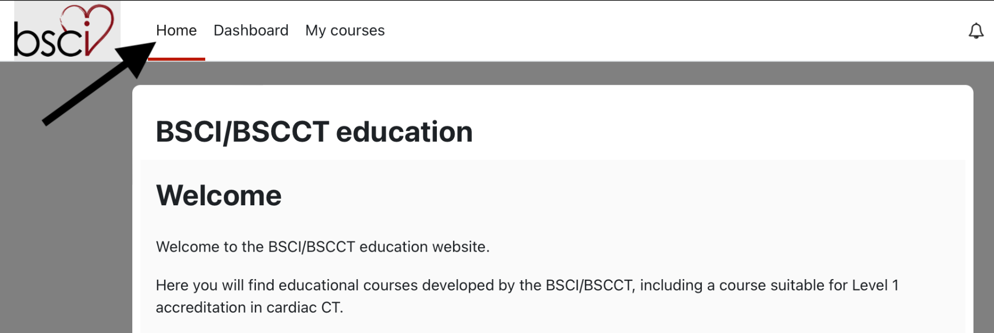

- Click on one of the available courses

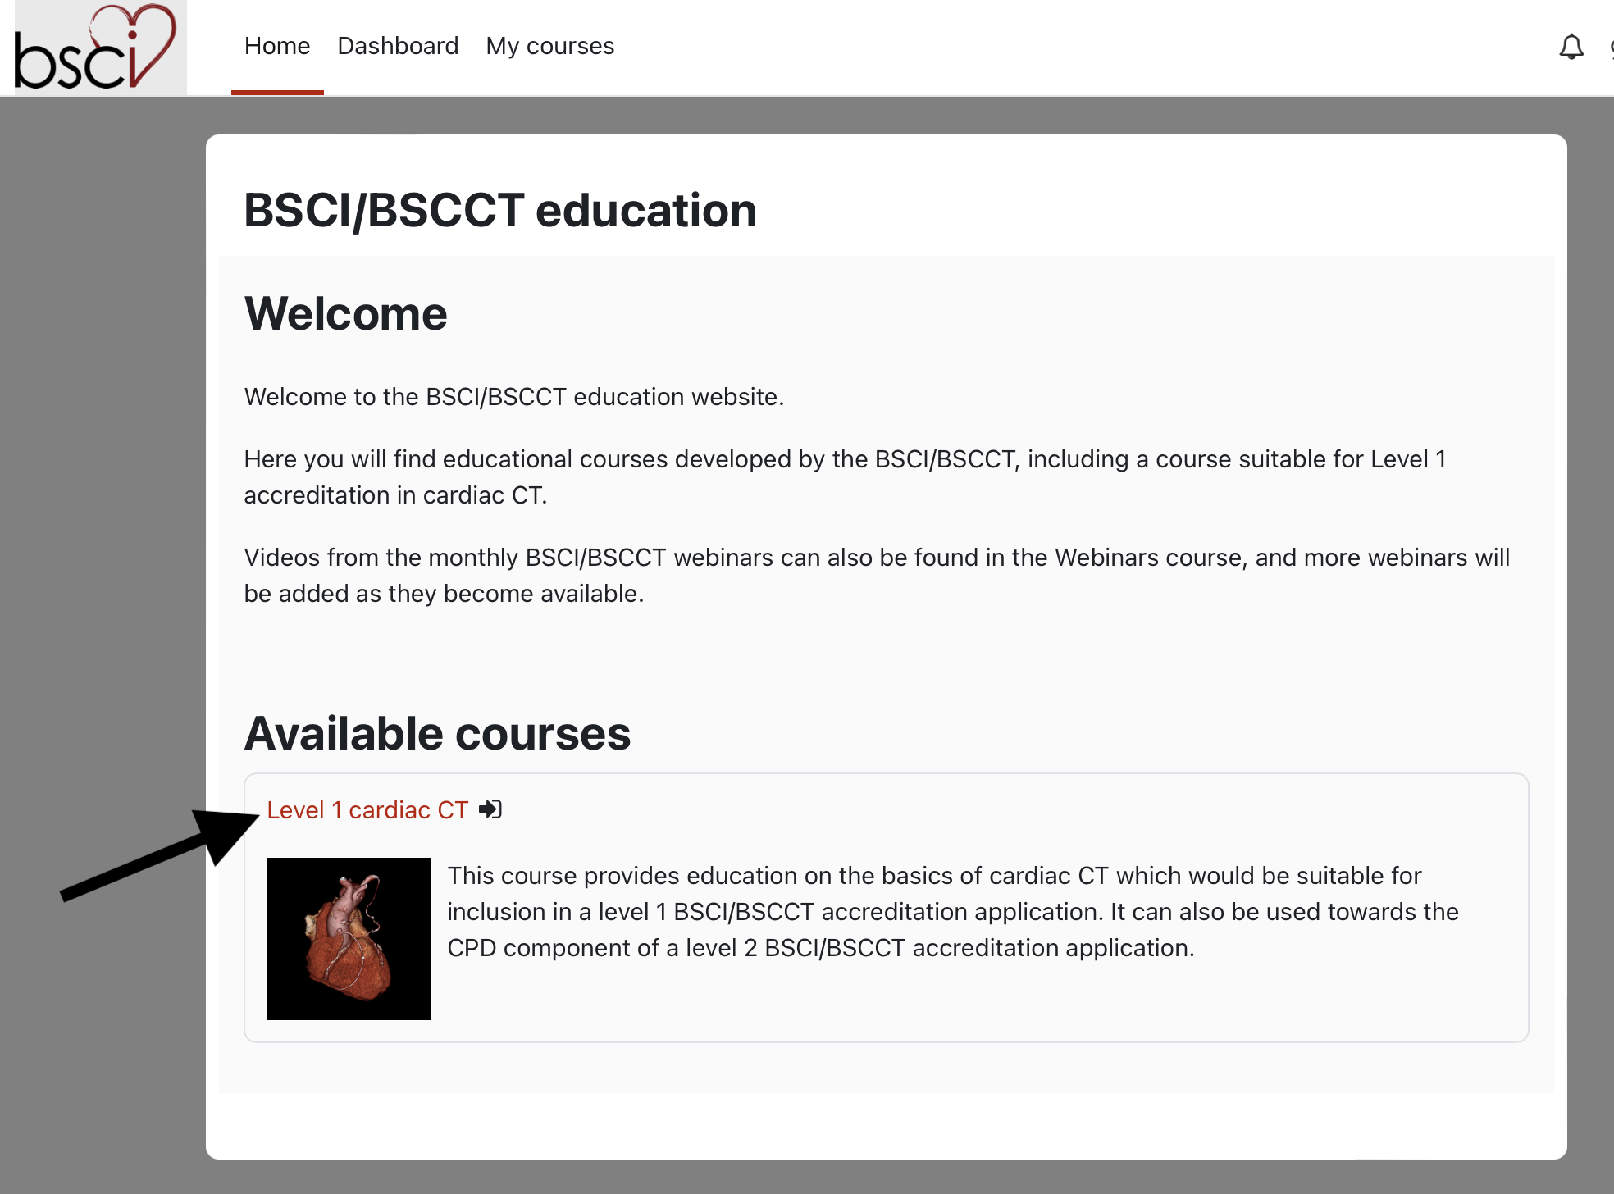

- Click on Enrol me

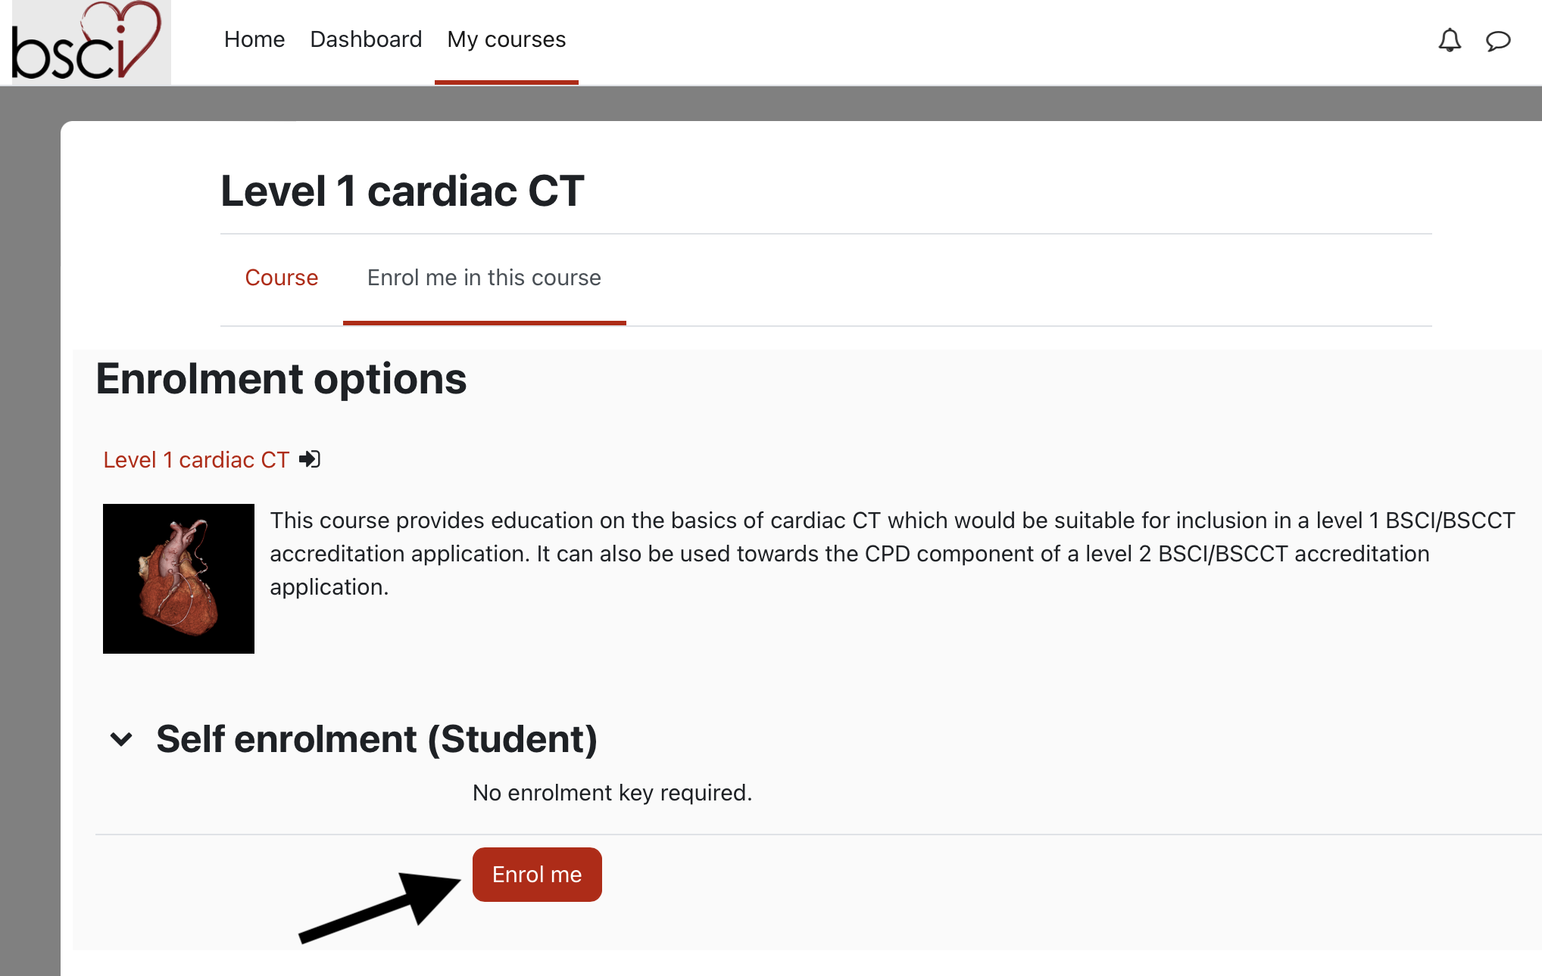

- Work your way through the content by clicking on the different pages.

- For courses where there are certificates (e.g the Level 1 course) these will become available once you have watched all of the content and completed any assessments that are part of the course.

