BSCI/BSCCT Clinical Case Submission

THURSDAY 22nd & FRIDAY 23rd SEPTEMBER 2022
BSCI/BSCCT Annual Meeting, Bath Assembly Rooms, Bath

Abstracts are now invited for the joint BSCI/BSCCT multimodality imaging case report session which will take place at the BSCI/BSCCT Annual Conference 2022

Case Reports Submission Deadline
Friday, 1st July 2022
Please submit your completed form to abstracts@bsci.org.uk

Successful applicants will be invited to give an oral presentation. Submission should be focused on clinical cases where imaging has played an important role in the diagnosis/management/follow-up.

A monetary prize towards educational expenses will be awarded for the best presentation.

The most highly rated cases will be selected for publication in the EHJ: Case Reports.
Patient consent form required for journal publication (https://academic.oup.com/ehjcr/pages/general_instructions#Consent).

Abstract submissions should be no longer than 250 words. Please send a word document (.doc) including:
- Abstract title
- Full names of all authors
- Author affiliations, including country
- Corresponding author’s e-mail address (including alternative e-mail address, if available)
- Please also email a signed copy of the Abstract submission form supplied on the following

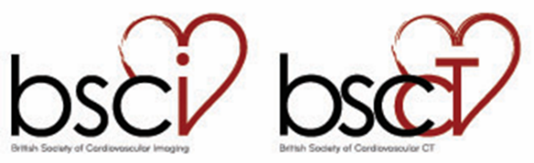

BSCI/BSCCT Case Report Session

Abstract submission form to be completed by the corresponding author

Abstract title:

Author names and affiliation:

Corresponding author’s e-mail (including alternative e-mail address, if available):

Background
Case Summary
Discussion

You may include one accompanying figure

Signature of corresponding author ……………………………………………
Date ……………………………………………

